Background

EDUCATION PROFILE:
Mr. Kyle Bartlett
I grew up in Bellwood and graduated from Bellwood-Antis HS (2013). I went on to attend Shippensburg University (2017) where I graduated Magna Cum Laude with a Bachelor of Science degree and a Secondary Mathematics Certification. Then I received my Master of Education Degree from Saint Francis University (PA) with my K-12 Principal certification. 2025-2026 marks my eighth year of teaching. I have experience teaching Algebra, Geometry, and Trades Mathematics. Some of my professional interests and studies include modern mathematics education, education reform, modern teaching methods, and inclusive practices.
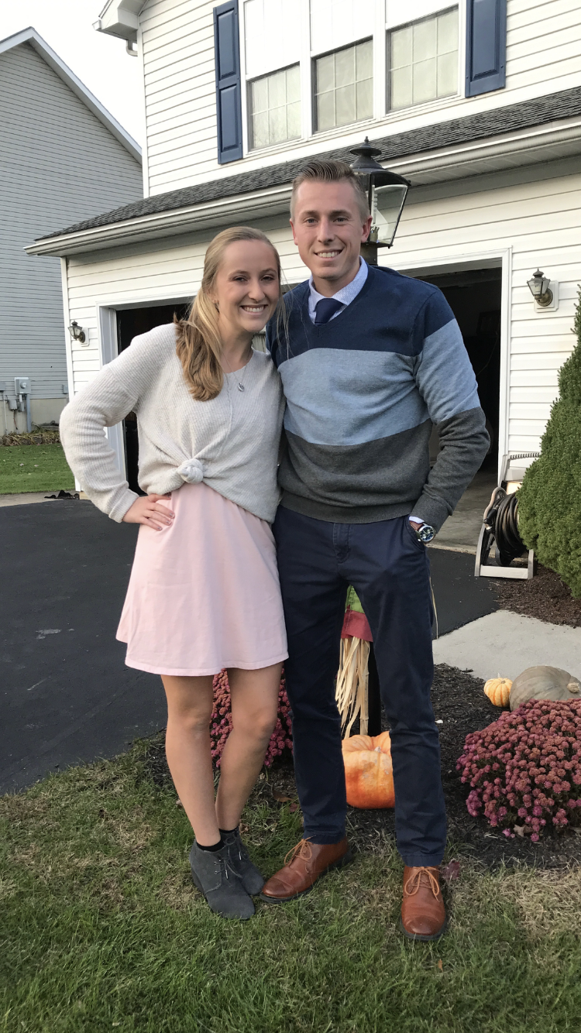
Outside of teaching, I'm a big-time sports guy; most likely you'll catch me on the golf course or at an Altoona Curve game. I have my favorite teams, but if they are playing anyone from Pittsburgh then I tend to root for Pittsburgh. I also love to coach and have experience coaching soccer, basketball, and track and field. Other than sports, I enjoy camping, watching TV (Diners, Drive-Ins, and Dives, Ancient Aliens, Pawn Stars, The Price is Right, Wheel of Fortune, Jeopardy, etc.) and spending time with my wife, Kaylie.

Motivation Behind My Education Philosophy
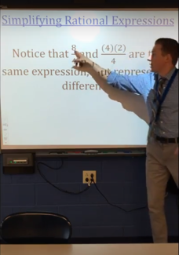
For centuries, humans traveled on foot. But, as time passed, we found new ways of getting around: animals, the wheel, boats, trains, planes, and cars. For centuries, humans could only write letters to communicate. But, as time passed, we found new forms of communication: telegraphs, home telephones, cell phones, and social media. For centuries, we could only study the skies with our feet on the ground. But, as time passed, we found a way to make one giant leap for mankind. I could list hundreds of examples of how far we’ve come since our humble beginnings. One item would not make the list, though: education, and many impediments have contributed to this.
For centuries, education reformers have tried to invent new techniques, such as a mastery-based curriculum with student centered team activities; spread new ideas like discovery learning and playful explorations to make class time more enjoyable for students; and offer new suggestions to reach more students: free choice of seat, reduced homework load, etc. Their passion to drastically change, however, has resulted in severely harsh backlash from traditionalists who have said, “not so fast!” Some traditional retorts include that students in rows preserves organization and attends to formality. This disciplinarian mentality resonates to student assignments – why would the students know what to choose to learn about if the teacher is the one in charge of how they learn? The teacher should be the knowledge lecturer! “And don’t even tell me to reduce homework, I’ve been doing it this way for 30 years...”
So…to be a teacher in 2025 is HARD, to say the least. Baggage, divided visions, skewed misconceptions, incorrect labels, and negativity from the wars put a black eye on the profession. The more that I research educational change and reform, the more I ask myself why does anyone have to be right? Why haven’t we put students first? Does there have to be just ONE way when all students are unique? Why can’t educators put in the effort to blend mentalities to influence positive change?
Future Goals as a Principal/Tentative Philosophy
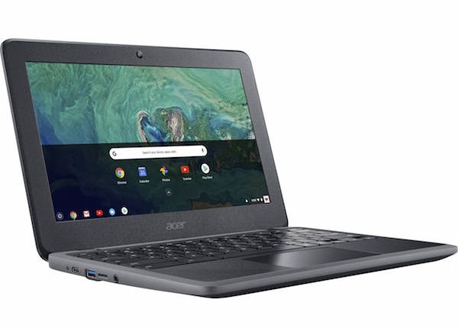

https://www.google.com/url?sa=i&url=https%3A%2F%2Fwww.brotherrice.org%2Fproduct%2Fchromebook%2F&psig=AOvVaw2yo49hNBLmuNfTTqgvkA3z&ust=1598211630507000&source=images&cd=vfe&ved=0CAIQjRxqFwoTCJi7ybjIr-sCFQAAAAAdAAAAABAD
After my first week of my first year of teaching, I knew something just wasn’t right, but I couldn’t put my finger on what it was…all I knew is, I wasn’t giving the students what they deserved. As my first year went on, I blamed myself while trying my best to give my all to my students. When the year concluded and I was reflecting over that summer, I had a huge realization. It wasn’t necessarily me that was the problem (it was also not the fault of the other teachers, the administrators, or the curriculum director). The problem was school itself… And notice that I did not use “the school” – the school district that I was in was phenomenal. It was the traditional, unchanging design of “school” that was the issue.
That summer, after many days of research and thinking, an idea came to me. The “flipped” classroom that my mentor teacher utilized during my student teaching practicum during his trigonometry course reminded me of a comment he made to me one day. He said, “I have never taught more in my life.” A flipped classroom, in brief, is a type of instruction that has the students learn by video at home so that more focus on one-to-one learning can occur in class. I don’t really care entirely for a flipped classroom model, as, again, I don’t believe we are giving our all to our students – what if some students don’t have Internet access, or time, or motivation? The idea that I came up with was NOT a flipped classroom; rather (and what I found out later is actually a real thing) is called "blended learning" and combines principles from a variety of teaching styles. Blended learning meshes aspects of video learning and face-to-face instruction. It encourages differentiation, discourse, manipulative use, and technology. More importantly, the model allows for the teachers to be “guides on the side,” not “sages on the stage.” Thus, blended learning gives teachers opportunities to work on individual levels with each of their students so that each individual student can be pushed to their maximum potential!
We must embrace technology and work to reform the way students are taught! Therefore, blended learning seems like a reasonable solution to provide students with an effective opportunity to learn. In conjunction with the blended style, students will be working at their own pace to work through course content. Once they finish a lesson, they must pass a mastery check. Students may watch a video that I make or choose to have direct instruction from me – they may choose both options! No matter what they choose, I will be right by their side to encourage and support them. In addition, “manipulatives” and “tech tools” are extremely important elements and will be heavily utilized to help reach every student, like GeoGebra, NCTM applets, and Canvas discussion boards.
I was so excited to walk into the administrative building, look at the superintendent of this massive district, and say, “IT’S TIME TO CHANGE HOW THINGS ARE DONE AROUND HERE! I GOT A PLAN LET’S GET TO WORK!” My girlfriend at the time (who is now my wife) stated that that probably wasn’t the best idea as I was just going to be a second-year math teacher…So I didn’t do it (of course) – instead, I focused on the concept of blended learning and tried to implement it in my classrooms in at least some substance each year since my second year. And this turned out to be good advice from my wife; my coursework and professors at SFU have been excellent and reiterated a nice suggestion for first-year principals: DO NOT try to change too much at first, especially on a large scale. Instead, take it slow, learn the ropes, and be plan oriented so when the opportunity presents itself to make a change, we can be ready. Among the gamut of needed reforms in education, instruction and teacher-to-student interactions need to be first priority. The modern learner is different than learners of the 1950s and ‘60s and should be treated so. I can’t wait for the opportunity to spread blended learning to a future school district because I think this is a natural step in the right direction to set up students for future success!
Current Teaching Philosophy
Eclecticism is defined as the concept of drawing ideas, styles, and methodologies from a broad, diverse variety of sources. At the heart of my teaching philosophy is the concept of eclecticism, because at the heart of teaching are students. ALL students are valuable and deserve nothing less than equity, dignity, and my very best effort to serve them. ALL students are unique; they bring along with them different personalities, different ways of learning, and different ways of thinking.
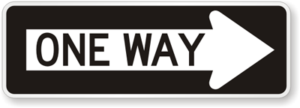
So, my instructional style is eclectically designed to meet the needs of ALL students. It is neither too traditional nor too reliant on every new, modern reform claim. My classroom environment is eclectic; it includes a number of different items used to build positive relationships and invite discussion. Curricular themes, goals, and activities in my class are tailored to benefit each student, not just learners who retain information faster than others. Classroom norms and policies are formulated on the basis of reciprocity and respect. I encourage students to come and talk to me if they need me to do anything better. I think that teaching for understanding and content mastery support student equity rather than a one-size-fits-all approach. Other important professional responsibilities that I need to account for, such as sequencing, homework, extrinsic/intrinsic motivation, course organization, lesson planning, (and many, many more) all have an eclectic, student-first backing. That being said, I have not found (and will not find) the “universal, ultimate” way – this is impossible since there is no one way!
Thus, I strive to progress in my craft each year. Just as times change, I will accept and adapt, be open and receptive, and constantly reflect on how I can improve teaching my students. I humbly accept past mistakes and look to get better in any teaching facet. However, adhering to an eclectic, change-receptive, student-first philosophy makes it possible to do whatever I can to make my students happy, valued, and successful. Now, I think we can all agree that that is the only way!
A Couple More Pictures…
Bottom Left: My wife, Kaylie, and me.

Bottom Right: Our two puppies (in front) and Kaylie’s older family dogs!
